Data Centered “Blackboard” Architectural Style

Rationale:
I have chosen to use the data centered blackboard style. This will consist of a central data repository and other software components monitoring and communicating through it. The nature of computation of the desired system and the nature of computation of the blackboard system are compatible for the following reasons:
- A data centered architecture has a heavy emphasis on data storage. In order for the system to function the data must be well structured. This is useful for the proposed system as a record of transactions could be kept in the central data structure.

Using the data centered black board architecture also has some quality merits that would prove useful in the proposed system.
- The black board architecture makes use of implicit invocation. This allows a simplistic and modular approach to the design. If a component requests another component to perform a task it will simply ask for “someone” to perform that task via the data repository / blackboard. This means that a component can be replaced as long as it responds to these implicit requests correctly.
- As the data is all in one place it would be easy to implement another component that does some analysis on the data for marketing / finance purposes.
- Data centered black board architecture allows for easy up-scaling. The amount of processes interacting with the data can be easily increased. In the context of the proposed system this means additional pumps or cashiers can be added with little effort.

Component and connector description:

- Pump Input
  - These are the raw inputs coming from the real world. These include the pump pick up sensors to detect if a pump has been picked up and which one, and the fuel flow sensors.
- Input conditioner
  - This is an active software component that looks at the raw information that has been placed in the data repository by the input sensors and converts the inputs into something meaningful. It will provide the following functions:
    - It will take the raw flow sensor input (12bit float representing flow rate), convert it into liters per second and be responsible for performing the integration required to get the volume of fuel taken / being taken in real time.
    - Calculating the cost of the fuel being taken using the volume as calculated from the flow sensors, the type of fuel being taken inferred by the nozzle pick up sensor and the price per liter for a given fuel as stored in the data repository.
- Pump user interface
  - This module will take the conditioned inputs from the data repository (as conditioned by the input conditioner module) and provide a user display at the pump. This is a passive component and will be triggered by the input conditioner module (nozzle pickup). It will display the current amount of fuel taken and the current price for that volume of fuel.
- Transaction Manager
  - This is an active software component. It will perform the following functions:
    - It will continuously monitor the data being accessed and modified by the input conditioner module. Once it detects a volume of fuel has been taken and the nozzle has been put back in the holder it will generate a transaction record in the data repository. This will contain the pump ID, the type of fuel taken, the amount taken and the price of the transaction.
- Cashier session
  - This is an active software component that becomes active once a cashier has logged in, once the cashier has logged in this will stay active until the cashier has logged out. It will provide the following functionality:
    - If a transaction is not currently in the control of another instance of the cashier session it can take control of that transaction in the data repository created by the transaction manager. It will then mark this transaction record as “locked” to stop concurrent access. It will do this by setting a bit in a status word contained within the transaction record.
    - Request a payment to the “secure payment” module via the data repository. In practical terms this will set a bit in a status word in the transaction record that the “Secure Payment” module will be looking for.
    - Mark the transaction as being completed or void. Again, this will be done by setting some bits in a status word in the transaction record and depends on the outcome of the operations performed by the secure payment module.
- Secure Payment
  - This is an active software component that is continuously monitoring the transaction records status word. When it detects a transaction that needs to be paid it will carry out the secure payment. Once completed it will set the status word to “paid” or “void” so the cashier session can complete the transaction and unlock the record.

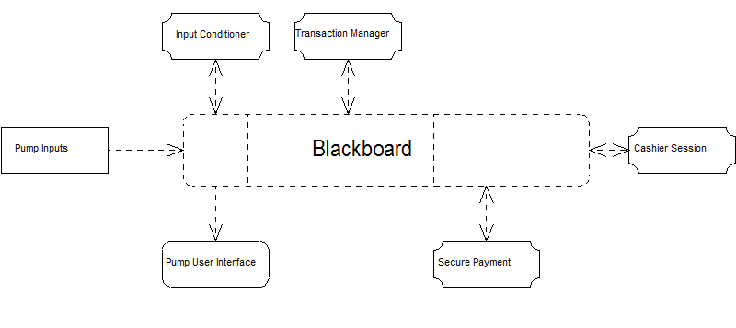

Data Centered “Blackboard” Architectural Style

Evaluation:
Scenario |  |  | Change
No. | Description | Type | Component | Change
1 | User wants to add the facility to charge electric vehicles. | In-Direct | Input Conditioner | Input conditioner will have to be modified to deal with the different format
1 | User wants to add the facility to charge electric vehicles. | In-Direct | Pump UI | UI will have to change slightly to reflect the new units
2 | User wants to add a new pump from a different manufacturer. | In-Direct | Input Conditioner | Only this component will need to be modified to interpret the new signals
3 | User wants a new interface for the cashier with touch screen | In-Direct | Cashier Session | This component would need to be modified as it contains the user interface
4 | User wants to accept payment via an NFC device | In-Direct | Secure Payment | This would need to have the NFC protocol added.
5 | User wants to add pay at pump facility | In-Direct | Input Conditioner | This would change to take payment details input
5 | User wants to add pay at pump facility | In-Direct | Pump UI | This would change to display payment status
5 | User wants to add pay at pump facility | In-Direct | Transaction manager | This would need to be changed to interact directly with the secure payment component. This would cut out the cashier component.
6 | User wants to add an additional grade of fuel | In-Direct | Input Conditioner | This would need to be changed to recognise a different pump is used
6 | User wants to add an additional grade of fuel | In-Direct | Pump UI | This would need to be changed to reflect the additional fuel.
7 | User wants to add another pump. | Direct | No change necessary
8 | User want to add another cashier console | Direct | No change necessary
9 | User want to add the ability to combine multiple pump usages into a single transaction | In-Direct | Transaction manager | This would need to be modified to be able to combine multiple pump uses into a single transaction. This module decides what constitutes a transaction so should be the only component that needs to be modified.

Scenario Interaction:

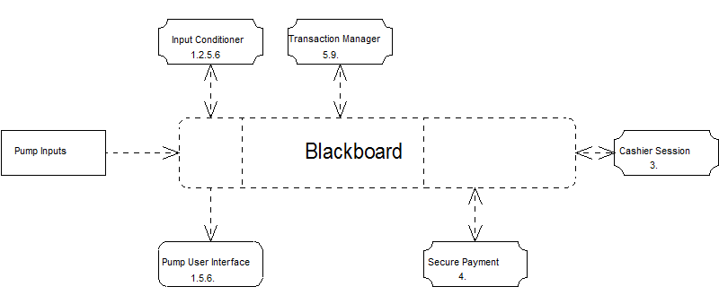

From the above diagram we can see the interactions of the different scenarios. Note that the blackboard itself isn’t technically modified, it is a central data structure that remains constant. Modifications are only applied to the processes.

